CRM 7 Discussion #2 4.8.26
4.8.2026 |  | 9:00AM – 11:00AM CST
Team | Customer
Facilitators | Jose, Dawn, Tara, Shibbu
Note taker | Taylor
Attendees | Dawn, Jose, Tara, Taylor, Shibbu
Notes:
SIMPLE MDG
SimpleMDG will likely only be used in Back office
SimpleMDG can integrate with CRM, S/4, and Service Cloud but Question remains if the User Interface is friendly enough to use
Simple MDG originally supposed to be Release 1, they’re currently doing a POC
Want to use MDG for Vendor Management (Vendors currently a mess)

IDENTIFICATION / SEARCH
Annie Match -> All Genesis
Enhancement
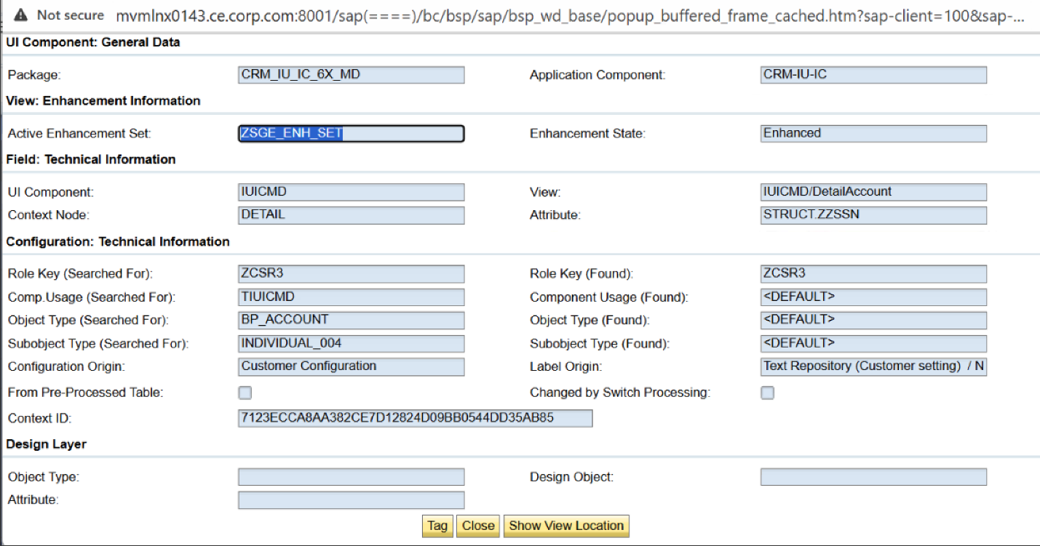

Priority communication and Restoration = for hospitals and schools (indicates urgent notification)
1 Loan = Charge to hook into the main

Custom Messages – VCC Business 1-855-477-9027
Dawn to get list of Custom Messages

BP MAINTENTANCE
Need to keep Household and Income details
puts a BP id on the BP to give eligibility for different benefits
you can manually add BP ID
BP ID only stored in ECC Table, which updates eligibility

- Address Maintenance ECC Screen
  - Using all standard address fields
- Forms Menu
  - Majority is ISIS
  - Need to figure out what system is feeding the Forms Menu

FACTA – Welcome email with Link, but never receive the Link that CSRs send out
- Just sending the FACTA link
- Maintaining the link in Power BI App and links back to specific requests of customer
- Leverage table

How are we fetching this missing link?

Dunning Notices you can view history in Correspondence in Interaction records (only store time stamp of when it was sent- this was a business decision with archiving)
Welcome Letters- they don’t store archived history

When Agents need help with Fraud
- Power App (connects directly with CRM, no BW) –> Fraud forms (questionnaire style to get to form)
- Theft
- Estates/ Deceased
- New/End Contract
- Dawn to get Screenshots of CSR Fraud Forms
- There is a role for Fraud and Theft in C4C

Fraud similar to CSR roles, but slightly different

OUTAGE CREDIT REPORT Launches to ECC
- Keeps track of outages that lead to outage credit

INTERACTION RECORDS
- Currently use the search function for unknown

CUSTOMER CONSENT
- Purpose: View Only
- Variety of ways customer can submit formas
- In one forms menu – they send a link to customer and it takes them to website, or they go directly on the website and enter the forms which populates ECC
- Pulls from ECC Table
- Integrated through OneTrust, links directly to SAP
- Pulls from table that stores information in ECC
- Will cross reference to other accounts
- BP from Shibbu: 1031036211
- Table from Shibbu: ZTFO_CONSENT
- There is structuring to messages, limitation to messages (things about 6)
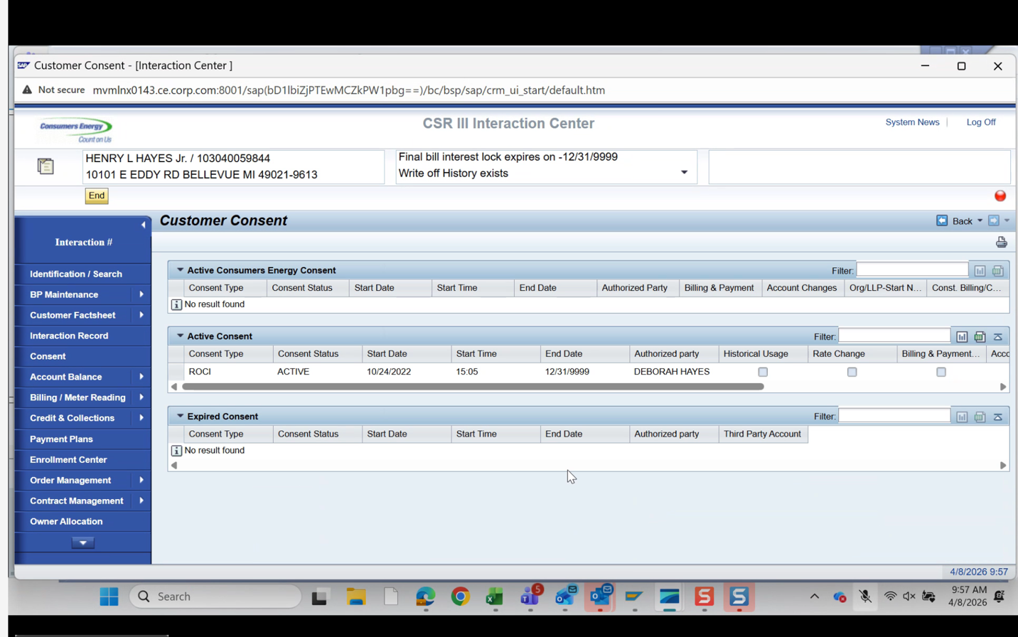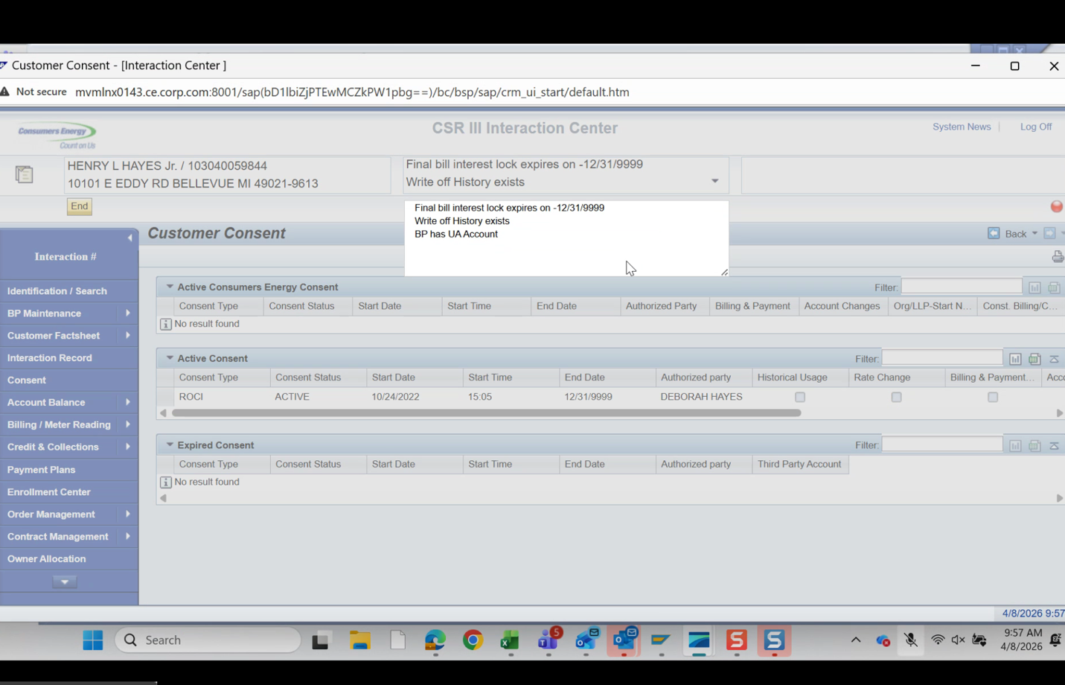

- TOPIC FOR EXPLORE: Messages should be more obvious in Service Cloud 2

- CSR can send Consent form from CRM (User 1 would have to call and if they are not Authorized, then User 2 (Owner) Authorizes, then User 1 would complete the consent

- DESIGN CONSIDERATION: Obtaining Consent as part of Move in Process, embedded into the welcome email

Account Overview
- Displaying what is in FPL 9
- If it wasn’t past due it just says total balance
- Lock - You can add new lock and decide what kind
- Not 1:1 in ECC, but only showing locks for CSR
- Consumers Allows CSRs to place locks on account

Balance Overview is never used
Special Installment Plans, Care
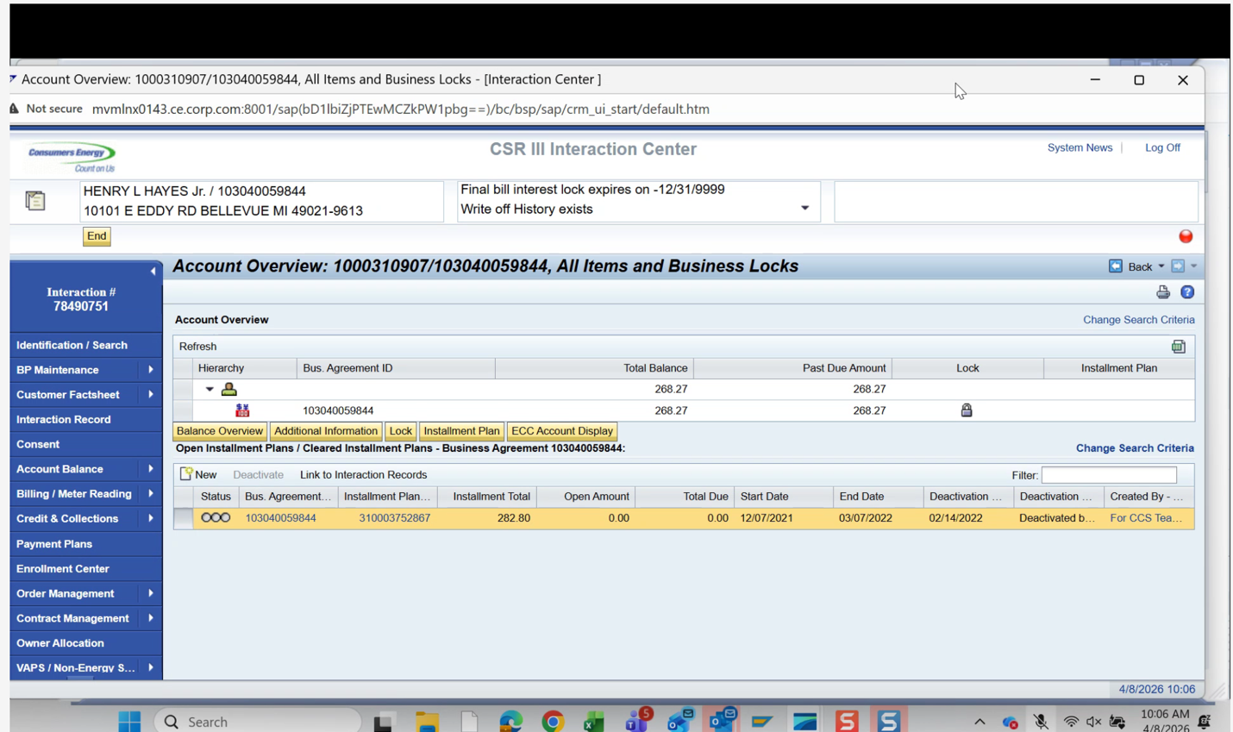

Installment Plan: All Custom
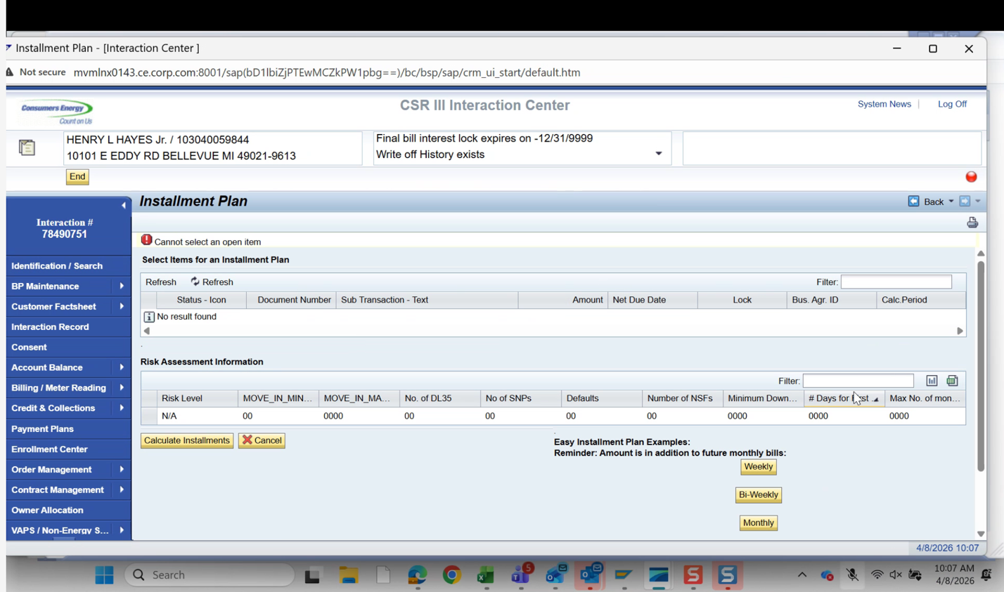
Organization BP Types:
- Flex Pay & Standard IP (Orgs, Org BP on Residential rate Residential customers)
  - Out of CSR Role, you can set that up in a different Role
- Two different eligibility tables

- Eligibility table for Flex Pay and Standard

- As long as they have a bill, they can stlil do installment plan

- CARE – combination of payment and installment plan (for low income) not in CRM 7, in ECC, links with an Assistant portal
- Users In CRM will NOT see CARE in the normal installment plan
- Payment Plan Work Center = you can see the details for CARE

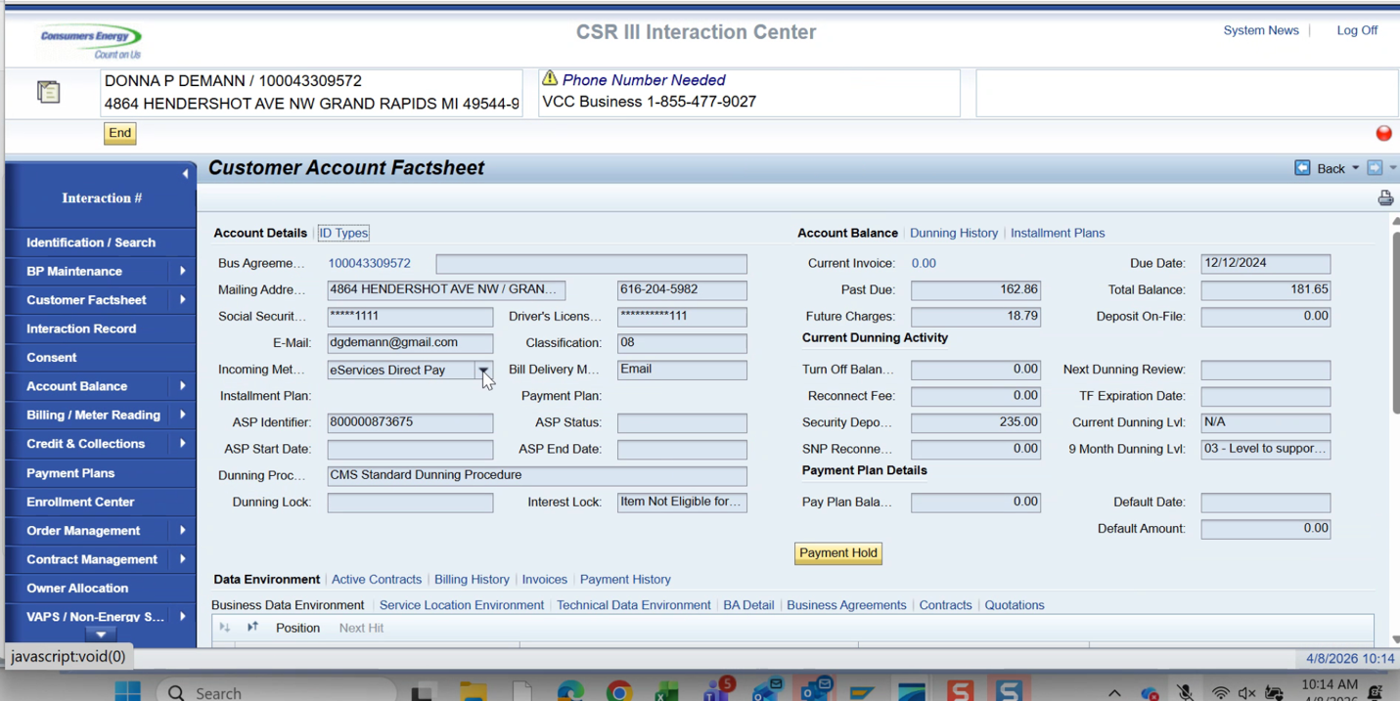

DIRECT PAYMENTS
Corporate Billing still does direct payments but puts its into Account Dashboard to add the codes
Integration- PAYMENTUS
Need to revisit Zfields in Business Agreement
CSR updates flag Pay mentis – process auto pay payments

Maintain alternate billing recipients. Shut off notices has an integration with one trust
Customer Select Due Dates (Payment Terms)

Fiserv Consolidated Billing. Daily Files, Business Customers, CSR doesn’t deal with Fiserv Customers
Removal done in Business Agreement CRM, different aspects happen outside of the system

Taken off Autopay done in Paymentus dashboard
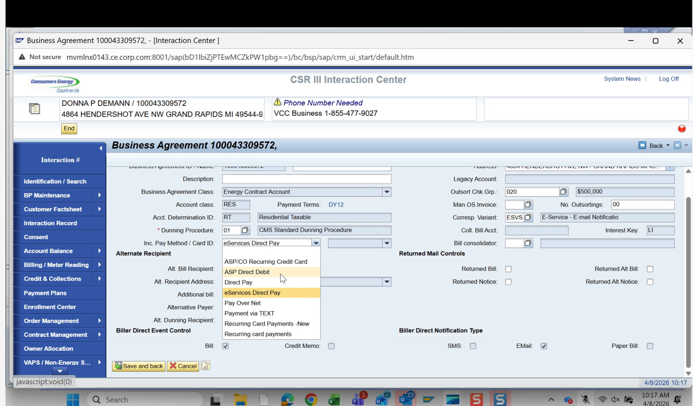

Bill Consolidated 0001 Checkfree (FiServ) and Bill Trust

Consolidator = who receiving the bills
Corresponding Variant = customer’s preferences on communication styles
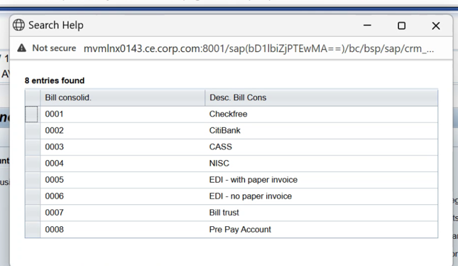

Donna can have 3 accounts and be billed in different methods

MISC CUSTOMER PREFERENCES
- Have to confirm contract account in preference center
- Launches to the WEB
- We should see emails tied to these preferences if they are enrolled
- Preferences at CA level not BP
- Nice to Have: Contract account at top of display for Web Portal
- It was an intention design to have Preferences go to Web Portal then to Kubra
- Anything with Kubra goes through the website

LATER PHAES: If Kubra Has inotify front end, Should be able to eliminate the web portal middle step

NICE TO HAVE: BP’s Business Partner Number is on the Welcome Letter
- (Cant have name + account number on the same document )

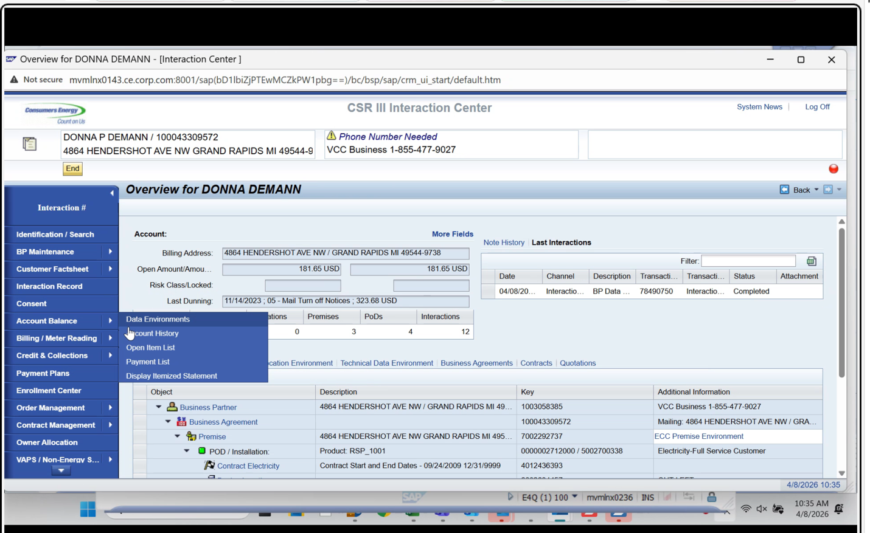

Training CSRs on FPL9

ACCOUNT BALANCE
- No longer store credit card info

Display Itemized Statement

OPEN TEXT
- Used mainly for archiving
- Not everything is getting archived (more billing related)
- Not sure on Forms archiving
- Non Archived Bill comes from ISIS
- After 18 months bill is archived from ISIS to Open Text
  - After 18 months CSR can’t see it they need to request request PDFs from Archive
  - Past 18 months the billing department will take care of that

BILLING OVERVIEW
- Where CSR needs Details for Usage Consumption NEED THIRD PARTY NAME Energy Use Details as a Third Party Vendor or Factsheet
- Actual Bills go to Billing Overview screen
- Consumption History is coming directly from ECC table
- Nothing custom within the table itself

Bill Correction Launch To Back Office
- CSRs are supposed to cancel bills instead of correcting
- MUST HAVE: Cannot do a backdate if they have canceled the bills

Bill Correction to cancel bill

ALL BILLING is BACK OFFICE
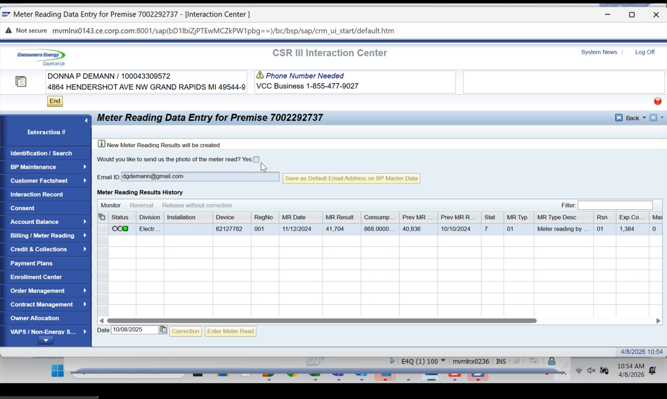

Photo is sent to PO Box

Non smart meters and or Gas they still want Photo option need to check the data to properly analyze

Allow Meter Reads manually
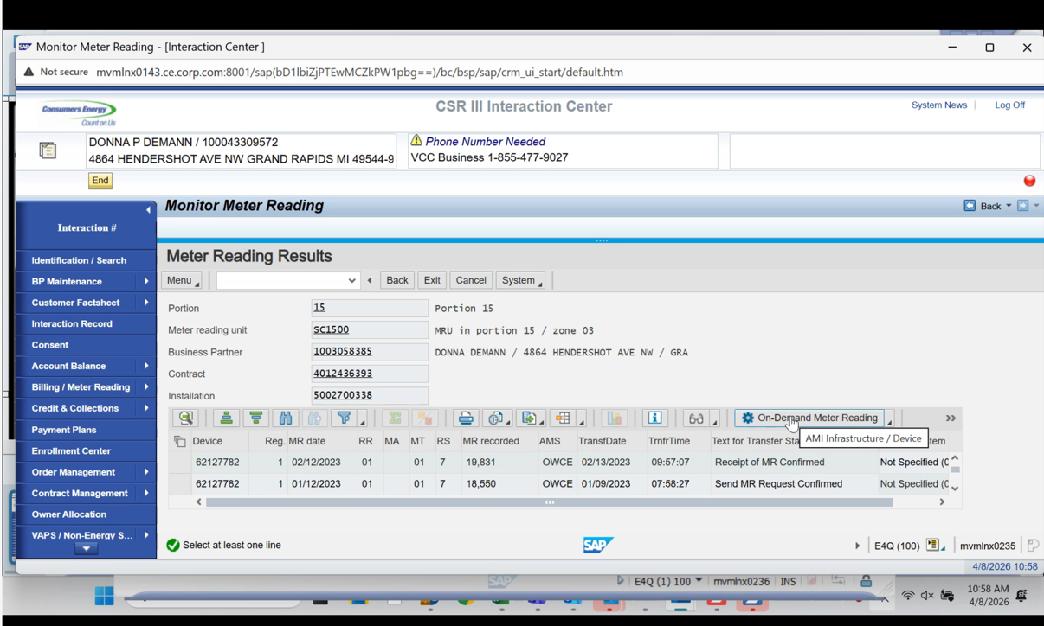

Other roles have to deal with SD invoies

3,000 SD accounts need to be in CRM 7

Key Decisions/ Outcomes :
- Fraud, Thefts, Estates, etc, Team will still need a role in the future since they do Move in and Move outs
- Messages should be more obvious in Service Cloud 2
- Obtaining Consent as part of Move in Process
- Fraud, Thefts, Estates, etc, Team will still need a role in the future since they do Move in and Move outs
- NICE TO HAVE: Contract account at top of display for Web Portal
- NICE TO HAVE: BP’s Business Partner Number is on the Welcome Letter
  - (Cant have name + account number on the same document )

- MUST HAVE: Cannot do a backdate if they have canceled the bills
  - 60 days- backdating has to go to an EMA Case
  - CSR will do the move out within the last 60 days then do the move out date
  - Autoreversal (custom) of bill if no resets are needed
  - Work around for pop up
  - Same thing for backdated move out or move in

- In the future CSRs should not be able to correct bills (originally they were granted that ability when CRM went live)
  - Launch to the backend for cancel

- 3,000 SD accounts need to be in CRM 7
  - New Construction, Damage Claim,
  - Theft and Fraud Billed on Separate accounts (3,000 Account)
- Ensure that when all the data is migrated, the number ranges need to have the full range so they can match front to back
Parking Lot
- Need to visit classifications // priorities under IDENTIFICATION
- Map out customer journeys to hand to OCM
- Need to look at RFCs
- Need to figure out what system is feeding the Forms Menu
- Non smart meters and or Gas they still want Photo option need to check the data to properly decide what we want to do in Service Cloud / if it’s worth the customization

START THURSDAY ON CREDIT AND COLLECTIONS
Action Items |  |  |  | Person Responsible | Deadline
Dawn to get list of Custom Messages |  |  |  | Dawn
Service Cloud Demo for Thursday Meeting  - Move in  - Service order creation  - Payment Plan |  |  |  | Jose and Mohanta | 4/16 Meeting
Need to add more detail to Forms in the BPML |  |  |  | Dawn to delegate
Dawn to get Screenshots of CSR Fraud Forms |  |  |  | Dawn
Master list of Interfaces, Zcodes, and integrations list in Sharepoint |  |  |  | Taylor
Find Fiserve ( should be on the Integrations List in Sharepoint) |  |  |  | Dawn

